Date: 2016.11.15

Changes:

**From:** Lee, Jacques   
**Sent:** Thursday, 03 November, 2016 4:24 PM  
**To:** Chan, Pei-Fong; Wai Keat, Loong  
**Cc:** Soh, Ivy  
**Subject:** Additional 2 Functions (Select All & De-select All) in WMS system in Order Creation --> Inventory Details

Hi Pei Fong,

As spoke, kindly help to add 2 function button of “Select All”/ “De-select All” in Order Creation → Inventory Details

It will easiest for us to “Select All”/ “De-select All” Inventory Detail when we allocate order.

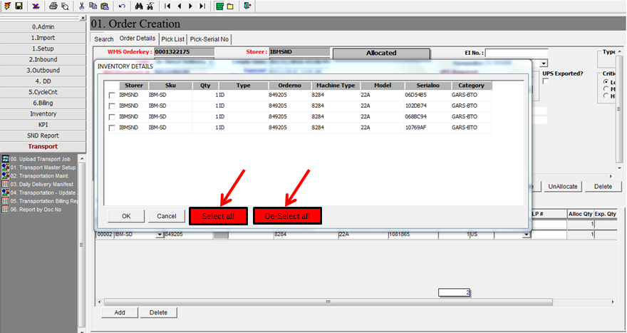

Kind regards,

Lee Jacques (Mr)

Contract Logistics/SCM

WMS Update:

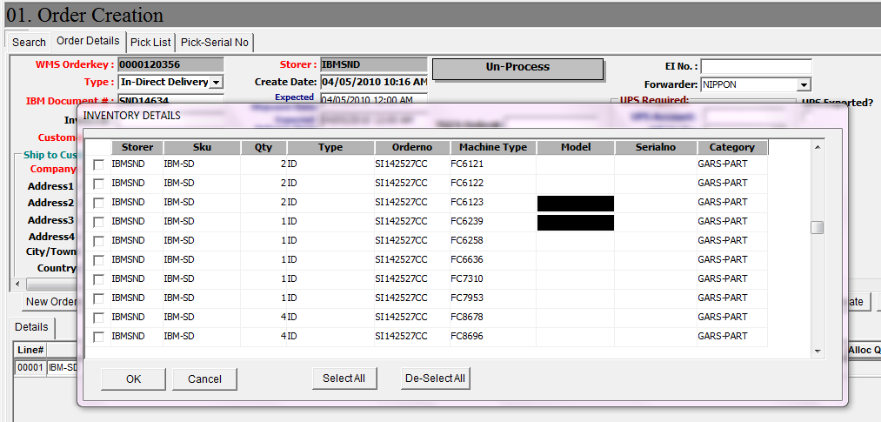

To select all records

To De-select all

* When click on [Select All]

